Lab Assignment – Data Visualization Exercise II

Shaun Pritchard

Rasmussen College

QMB4100

Darice Corey

April 18, 2021

Lab Assignment – Data Visualization Exercise II

In this lab assignment I completed the following task.

* Create a calculated field to show the total paid by local governments for lobbying.
* Create calculated fields for Compensation and Expenses.
* Create three different aggregation levels: SUM(total), AVG(total), and MEDIAN(total)
* Create a bar chart comparing the average to the median.
* Create a tree map to show how many different entity types there are.

1. **Which type of entity accounted for the most in lobbying spending, and how much was that?**

Cities Entity accounted for the most spending in total of $870,602

1. **What if you needed to get a sense of how much each of these gave as a percentage out of the total? Would you need another calculated field? What other ways, based on what we learned in the last module, could I contemplate exploring that?**

To get percentage types I could use the analytics panel and convert the datatype to percentage. Or I could calculate the grand total by clicking analysis and setting grand totals by column then used a calculated field to divide each total then multiple by 100 to get a percentage of the totals

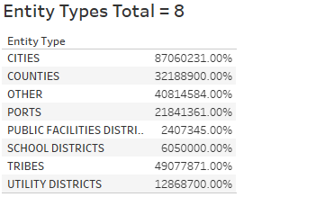

1. **Which type of entity accounted for the most in lobbying spending? How much was it?** Other entity type at $102,702
2. **Would it be newsworthy if the highly populated areas, such as King County, or the city of Seattle, are responsible for most of the lobbying to the legislature?** I would assume not because bigger cities seem more likely to involvement more lobbing and government involvement than smaller cities.
3. **What about smaller governmental bodies and how much are they paying lobbyists?** They are paying less than $3000 for lobbying compared to bigger entity’s Unless you total the entity type of other than expenses will be much more sufficient

